**Wayne State University**

**CSC 4110 - Software Engineering**

**Homework 1**

**Directions:**

**Do all problems by the due date. Follow instructions explicitly. See submission requirements.**

**\*\*\*\* Adhere to ‘General Requirements’**

**Assignment**

**TASK ONE**

**Read support documents carefully to Install Python. And then install Visual  
 Studio Code (VSC).Finally, configure VSC for Python.**

**TASK TWO**

**Go to following link, and list three interesting aspects of  
 Python. https://www.pluralsight.com/blog/software-development/why-  
 python (Links to an external site.) (or find similar article)  
 Note: if link doesn't work, do a general Google search.**

**TASK THREE  
Go to ‘command line interface’ and then get to “Interactive Mode.”  
 Type "import this"  
 Pick three statements that seem interesting; explain them.**

**TASK FOUR**

**Go to:  
 https://www.python.org/  
 Go back to homepage on the python.org site. Try scripts that are shown in  
 boxes 1 through 5. Paste code here:**

**TASK FIVE - please see Documentation, under Assignment Guidelines**

**Write a python script that accepts 'any' user input at least 9 characters long that prints three characters, in three lines, in uppercase letters. USE ONLY METHODOLOGIES GONE OVER IN WEEK ONE VIDEOS.**

**TESTED INPUT must be a combination of upper- and lower-case letters. All must be grouped to be aligned and on a separate line.**

**One input statement and ONE print statement.**

**Example:**

**asdFghjklvb**

**Becomes:**

**asd   
 fgh   
 jkl**

**SUBMISSION REQUIREMENTS:**

**Note1: for all screen shots/ screen scrapes, paste them all in THIS document.**

**Note2: see General Requirements**

**You will be submitting THIS document.**

**Assignment Guidelines**

1. Submit a screenshot of the code, itself for all four routines (must be commented per requirements)
2. A ‘screen scrape’ of the output for all routines
3. As required, documentation describing your opinion on the most efficient programming method.
4. Also, in your documentation, describe an ALTERNATE way you COULD have performed this if you had more time and unlimited funds.
5. See “General Requirements”

**General Requirements:**

**Add labeling/ comments (name, date, revision #); add in-line requirements where appropriate (such as syntax usage).**

#Indicate coding begin and end

Example acceptable code comment:

**# Revision number BEGIN/ START DATE**

**## Begin John D. Student here (date)**

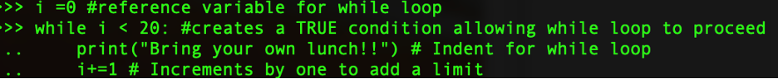

**# Revision number FINAL DATE**

**## End John D. Student here**

**# Group / manager/ lead tech/ project # ←-Where appropriate**

**Adhere to the following coding style (from PEP8):**

1. Wrap lines so that they don’t exceed 79 characters.

2. Use blank lines to separate functions and classes, and larger blocks of code inside functions

3. When possible, put comments on a line of their own.

4. Where appropriate, name your classes and functions consistently; the convention is to use UpperCamelCase for classes and lowercase_with_underscores for functions and methods.